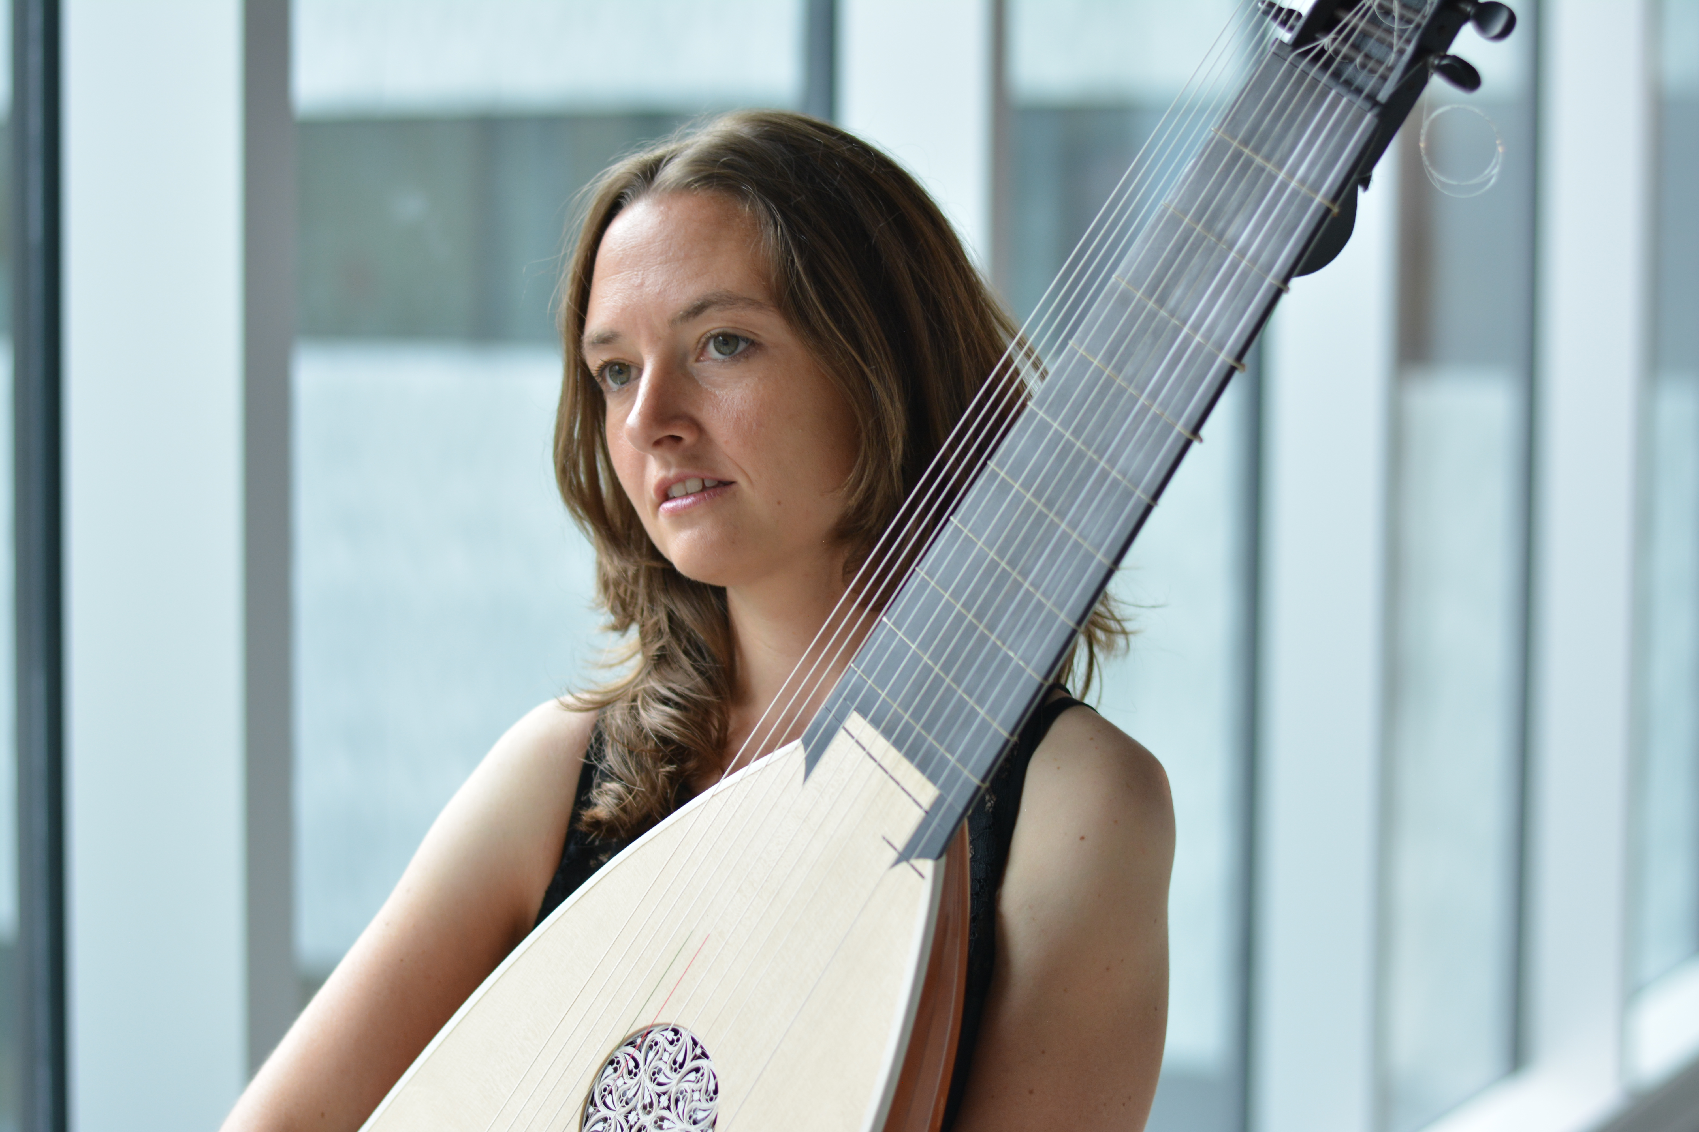
Priska Weibel

Priska Weibel was born close to Zurich, Switzerland. She studied classical guitar under the guidance of Carlo Marchione and lute, baroque guitar, basso continuo and historically informed performance with Yasunori Imamura. She graduated with a Bachelor's and a Master's degree from the „Maastricht Conservatorium“(NL) and she also holds a “diplôme de spécialisation” from the “conservatoire de Strasbourg”.

Before and during her studies she has won several prizes and special awards at national and international competitions including „Schweizerischer Jugendmusik“ and the competition „Andrés Segovia“ in Velbert (D). She was selected to take part in the European Youth Guitar Ensemble conducted by Leo Brower and received awards from the „Fritz-Gerber-Stiftung für begabte junge Menschen“ and „Bank Vontobel“.

Priska Weibel has performed as a soloist as well as in different chamber music formations and baroque orchestras under conductors such as Howard Arman, Martin Gester, Marco Zambelli and Harald Siegel among others. She played concerts in Switzerland and Europe at venues such as “Concertgebouw” in Amsterdam (NL), Culture House Reykjavik (IS) and Theatre Biel/Solothurn (CH). In 2013 she was invited to give a concert as well as master classes during the “Midnight Sun Guitar Festival” in Reykjavik (IS).

In 2014 she was founder and artistic director of a new concert series called “Erlebniskonzerte” where music fuses with painting, theatre, dancing, and other art disciplines. In 2016 she played concerts with “ArteMandoline” and the celebrated soprano singer Nuria Rial at the „Festival Saint Guilhem le desert" and the „Festival de l'abbaye de Sylvanès“ in the South of France.

A concert tour in Japan together with the ensemble Fons Musicae is scheduled for October 2017.

